Unit 4. Drama and comedy |  |  | School:№86
Teacher name:
Date: 12.12.2023
Grade: 6 A |  |  | Number of people present |  |  | Number of people absent
The Theme of the lesson |  |  | Drama and comedy. Genres of films
Objectives according to the curriculum |  |  | 6.3.4.1- respond with limited flexibility at both sentence and discourse level;  6.3.2.1- ask simple questions to get information on a limited range of familiar general and curricular topics;  6.2.1.1- understand a longer sequence of supported classroom instructions.
Objectives of the lesson |  |  | All learners will be able to:  Most learners will be able to:  • understand and use action verbs.  • reconstruct a story from pictures.  Some learners will be able to:
Evaluation criteria |  |  | Apply the rule for past forms to talk about past events in practice;  Differentiate between positive and interrogative past forms of verbs;  Apply past forms and time expressions accurately.
Level of thinking skills |  |  | Low order thinking
During the lesson:
The stage of the lesson/timing | Actions of the teacher: | Actions of the pupils: |  | Student actions with special educational needs | Assessment |  | Resources
The beginning of the lesson/  5 min | Greetings (1 min)  The teacher greets students; students respond to greeting and take their places.  Hello, boys and girls! How are you?  - Let’s revise our past lesson  Let’s review our task «Action verbs» at jamboard, matching verbs and pictures  - Brainstorming  - 1.Do you watch TV every day?  - 2. Do you watch cartoons or films?  - 3.What is your favorite film or cartoon?  - 4. Do you usually watch them at home or at the cinema?  - 5.What Kazakh films do you know?  - Positive atmosphere  Look at the screen  What was this video about?  Can you guess the theme of our lesson? What shall we speak about?  Today’s lesson is devoted to film. We’ll talk about the types of films.  Yes, of course you are right. | students respond to greeting and take their places.  Ss get task at jamboard by link and  matching action verbs with pictures  Ss answer for every questions  Ss answer for every questions  Students practice the words and positive character. |  | students respond to greeting and take their places.  Ss reremember action verbs  Answering and speaking  Answering and speaking  Students practice the words and positive character. | Descriptor  - for every right answer and speaking  - Check the answers  Get tickets for selected movie  Formative Assessment  (Good, excellent)  Descriptor  -Watch the video  -Answer the questions  - find the theme of the lesson  as: “Good job!  Well done!” |  | Workbook , IT, laptop  https://jamboard.google.com/d/1jwy8ORwHrHkni8C5B0IPAQwWcvSPOmyYt9DYHBcZH2w/viewer?f=0    https://www.youtube.com/watch?v=ZgRj3eC0d3I  (Жанры филмов)  Active board
The middle of the lesson – 35 min | Task 1.  First of all let’s refresh our vocabulary.  Words.  genre of film [ʒɑ̃ːnra ɒv fɪlm] —фильм жанры;  adventure - [ədʹventʃə] –шытырман оқиға  animation -[ʹænımeıʃ(ə)n] - анимация  action [ˈækʃən] — боевик;  drama [ˈdrɑːmə] — драма;  comedy [ˈkɒmɪdɪ] — комедия;  horror [ˈhɒrəʳ] — қорқынышты фильм;  historical [hɪsˈtɒrɪkəl] —тарихи;  science- fiction [ˈsaɪəns fɪkʃən] (sci-fi)—ғылыми фантастика  thriller [ˈθrɪləʳ] — триллер;  western [ˈwestən] —батыстық;  documentary [dɔkjuˈmɛntərɪ] — деректі фильм;  musical [ˈmjuːzɪkəl] — мюзикл.  crime [ˈkraim] – қылмыстық фильм  mystery [ˈmɪst(ə)ri]- тылсым дүние туралы фильм  romance [rə(ʊ)ˈmans]- романтикалық фильм  sport [spɔːt]- спорт туралы фильм  Now, please read the new words, please.  Tell me,What kind of films do you like?  Can you name one of them?  Do you like Kazakh films?  What Kazakh films have you watched recently?  Task 2 Reading . (PW) Leaners should make some definition about genre of films which named in the text  \  Task 3. Listening and test by worksheet. T. gives listening and test  Task 4. Where is logic? By jamboard T shows two different pictures  Task 5. Guess the genre of film. T shows short videos of different genres  Task 6. Team work. T Play Could you spell that, please? using the vocabularies | Listen, repeat, read  Students own answer  Students matches the genre of films with their explanation  Horror films feature lots of monsters such as Dracula. The object of these films is to make you scream and be afraid, very afraid!  Action films are films in which the heroes have lots of battles, do incredible stunts and drive fast.  Adventure films are like action films, but they take place in exotic places. These films include films about pirates, historical adventures such as sailing around the world and space exploration.  Comedy There are many different types of these films. In general, this type of film make you laugh - a lot!  Romance films are love stories made to melt our hearts with stories of people finding each other and falling in love.  Documentary is a film that investigates some real-life story that is very interesting for a number of reasons. Many of these films look at the causes of world problems or new types of scientific discoveries.  Ss. listening and work on vocabulary  Ss. guess what film is it and say what genres do they belong to.  Ss. guess what film is it and say what genres do they belong to.  Students follow the rule and play the game |  | Students can read and revise vocabulary with the class.  Students work on pronunciation and revise vocabulary.  Students read the questions and answer them.  Students work on vocabulary and read definition.  Students read the examples and complete the sentences.  Develop ss. mind  Students work on vocabulary  Students follow the rule and play the game | Descriptor  -Listen the words  -repeat  -read the words  Formative Assessment  (Good, excellent  Get tickets for selected movie  Descriptor  -read the definition    Descriptor  -read the question correctly  -Answer the question  as: “Good job!  Well done!”  Task descriptors  a)Complete the Mind Map with effective information  b)Compares their answers  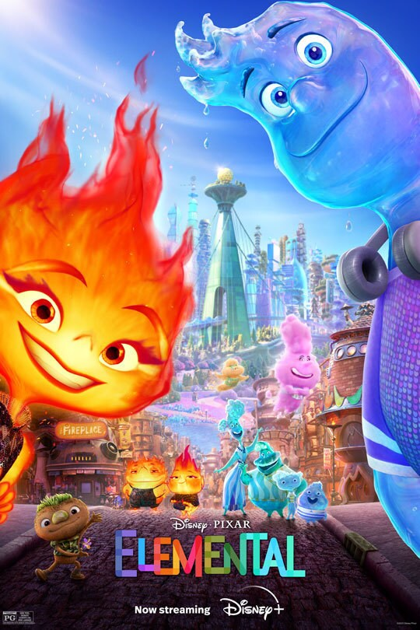  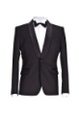  Feedback: Teacher evaluates by notes and give tickets  - find the name of the film  - find the of the genres of films  Students evaluate each other |  | Slides    https://www.youtube.com/watch?v=bg5LS0PpqA0&t=27s      Cartoon cards  Movie cards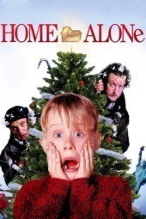  https://www.liveworksheets.com/w/en/english-second-language-esl/687343  https://jamboard.google.com/d/1_2yAuVT6XMcEN0DEZmjPq2t1p4TcYWg1diKa6j-3weU/viewer?f=0  https://www.baamboozle.com/game/1428660
The end of the lesson – 5 min | Homework (5 min)  Exercises 1, 2, 3 and 4 on page 33 of the Workbook.

